**2014 GOLF TOURNAMENT**

[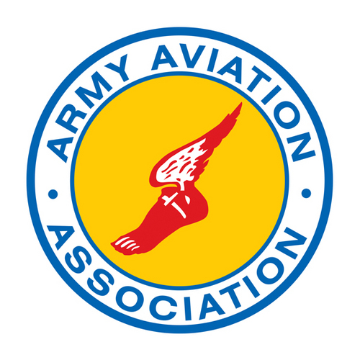](https://www.google.com/url?sa=i&rct=j&q=&esrc=s&frm=1&source=images&cd=&cad=rja&docid=C183bdU1JYnNjM&tbnid=nV5sEdP4rm2N2M:&ved=0CAUQjRw&url=https://twitter.com/Army_Aviation&ei=bqj9UZ79K6StigKRvoGwCw&bvm=bv.50165853,d.cGE&psig=AFQjCNGxh90EHfYS9HJTlrKRhkFz7bpISA&ust=1375664613174291)

**AAAA 2014 GOLF TOURNAMENT REGISTRATION FORM**

**TEAM NAME –**

**PLAYER 1-**

**PLAYER 2 -**

**For those who prefer to pay by check, make checks payable to:**

**Thunderbird Chapter AAAA, Attn: LTC. Jon Greenhaw  
4242 N. Mingo Valley Exp.  
Tulsa, OK 74116-5200**

**HOLE SPONSORSHIP**

**Multi-level sponsorships available.**

**HOLE SPONSOR POC: CHRISTOPHER LACKEY (405) 217-8108**

[**CHRISTOPHER.K.LACKEY.MIL@MAIL.MIL**](mailto:CHRISTOPHER.K.LACKEY.MIL@MAIL.MIL)

**ENTRY POC:** **TIMOTHY HUNT (405) 217-8132**

[**Timothy.d.hunt.mil@mail.mil**](mailto:Timothy.d.hunt.mil@mail.mil)

**Return this page to Mr. Hunt (hyperlink) and he will send you a confirmation e-mail of your registration along with the tournament notes.**

**DISTRO A will send e-mail when max capacity is reached.**